Prior to being able to queue, players need to register so the bot can keep up with their profile and stats. the command **/register** will send instructions to the users Discord inbox and they will need to indicate the following

* Riot ID (ex. Name#1234)
  + Bot should keep track of ID’s and not allow duplicates.
  + Riot ID should be in this format **Name#1234** if it’s not, show error messages
* Regions (NA, EU, LATAM, KR, BR, AP) this should give them a region role in the discord
* Valorant Dev Tools to verify players ranks. If player is not ranked in Valorant database then they must rank in before registering to use the bot (Bot should use Valorant API to validate account and player rank)

I would like this bot to create game queues. For right now I would like it to be Valorant 10 man queues.

Key Features I would like are the following:

* Queue handling (Queue as a team or solo queue)
* Vote for captains or auto-pick captains
* Pick or randomly assign teams
* W/L loss tracking (Team will enter command that indicates that they lost or won)
* Skill ranking system

Sample Scenario

* Player(s) use command **/q OR /queue** to create or add themselves to a queue. (**/l** OR **/leave** to leave the queue)
* When 10 players have queued, the bot creates voice channel for queued players to join.
  + If not all players are in voice channel within 5mins then the bot will disband the queue
* After players have joined voice channel, they are asked if they have preset teams or if everyone is solo queuing
  + If they are preset teams, the bot will ask for two captains to identify themselves and they will both proceed to choose the players in the queue to be a part of their team
  + If everyone there is solo queuing, then everyone will Vote for Captains or the bot randomly selects one.
* Captains are then able to pick their team and the teams are then displayed afterwards.
  + Solo queing: will pick players One at a time, so Captain A picks 1st teammate then Captain 2 picks 1st team then they move on to picking the 2nd teammate and so forth.)
* Once teams are pick/assigned, bot creates voice channels for both teams to join and players are sent a Direct Messaged with the Captains Riot ID so they can add them.
* The bot should also randomly select which map players will play on after both captains ban 2 map. (I’ll need the ability to update the maps, as this will change per season. If this can be built in as a command, that would be ideal)
  + Ascent
  + Bind (Currently Removed)
  + Haven
  + Icebox
  + Split
  + Lotus
  + Pearl
  + Breeze (Currently Removed)
  + Fracture
* Once teams have completed the match, winning team’s captain enters **/w** in the **match-results** channel to indicate the Win for their team and a Win as assigned to their stats and losing team has a loss assigned to their stats. He will go through the following prompts to add to their stats.
  + Number of rounds played
    - The Bot should ask for the winning teams number of rounds won agains the number of round the losing team won (the number of rounds the winning team lost.) So if the Winning Team Captain says they won 13 rounds. They bot should then ask how many rounds they lost and in this example it would be 7. After inputing this, the bot know that the winning team won 13 rounds and the losing team won 7 rounds so the score would be the following for both teams
      * Winning team: 13 – 7
      * Losing Team: 7 -13

Players should be able to see their Win/Loss averages. And Round Win/Loss percentages under their stats

The bot will need to keep their stats for the season (I’ll also need the ability to reset stats and have players resubmit their ranks via Riot API for the new season.)

The Bot’s Ranking system should go as follows Ranking System is called XP Points

* Every Round win is 1 XP
* Every Round loss is -1 XP
* If the game is won, they receive an additional 5 XP
* if the game is lost, they are deducted an additional -3 XP

Example, Game goes to 24 rounds. (13 rounds won and 11 lost) Winning team will receive 13 XP for each round win, -11 for rounds lost and an additional 5 XP for winning the game for a total of 7 XP. Losing team will receive 11 XP for the number of rounds they won, then deducted for rounds lost 13 XP but are deducted -3 XP for a total of -5 XP

Formula will be

**Team Won Formula**

* (Rounds Won - Rounds Lost) + 5
* Ex. 13 -11 +5 = 7

**Team Lost Formula**

* (Rounds Won - Rounds Lost) – 3
* Ex. 11 - 13 - 3 = -5

**Overtime Win**

* Winning Team will receive only **7 xp** no matter how many overtime rounds played

**Overtime Loss**

* Losing Team will receive only **-2** **xp** no matter how many overtime rounds played

Overtime Draw

* 0 xp if there is a draw (Round Win’s = Round Loss)

Players will not rank in until they have played 5 games. New players will start with **190 XP** should accumulate from here.

**Rank Tiers (Each rank is a role in the discord. If the player ranks up from C to B rank, then they lose their C rank role and acquire the B rank role which should give them access to the B rank chat and lose access to the C rank chat. This should work in the opposite way should the player be demoted.**

F - (-80 XP)

E - 10+

D - 100+

C - 175+

B - 265+

A - 355+

S - 445+

Below are the Instructions on Discord For New Memebers. This might help with how the bot works currently

**Team Xplicit Presents: Valorant 10Mans Walkthrough** -To begin, you will first need to register your discord with our Bot. Head to the **#register** channel and type **!register** in the chat and receive additional instructions in your DM.

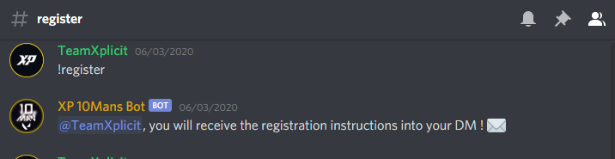

You will be asked for your **Riot ID** and your Region. Please be sure you add your Riot ID with your number. (**ex. TEST#1234**) Follow these instructions and you will then be ready to start competing with your fellow Valorant Players

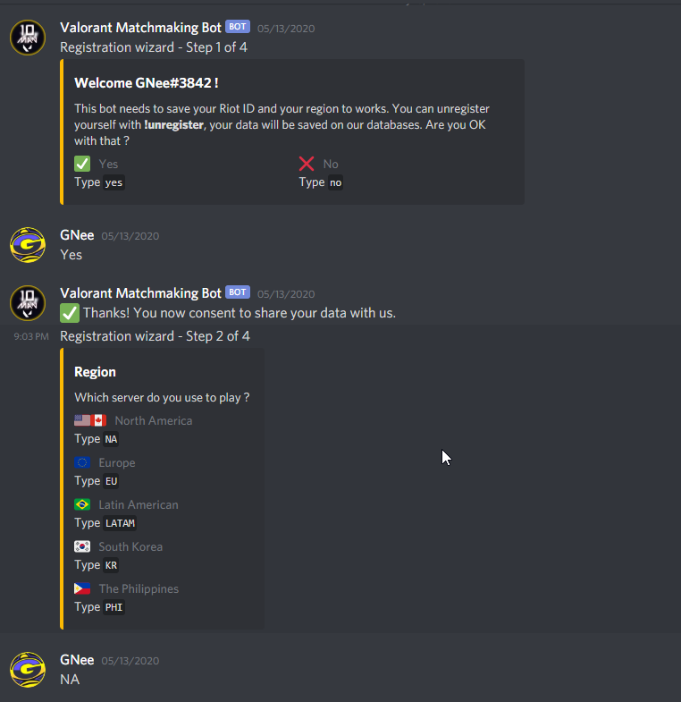

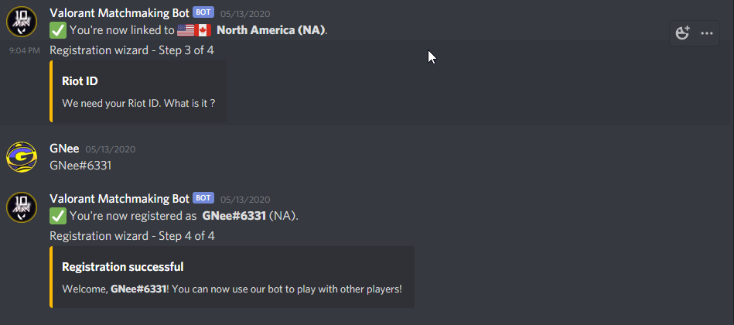

Here I would like the API to validate the players Riot ID and Rank

After registration, you will be allowed to begin queuing up with other players. (Note: everyone will start with 190xp (Rank C) , but after your first 5 games (that have been reported) you will have an official rank whether that be a rank where you ranked up to B or down to D. (Eventually, when we have enough players, They will be placed in different ranks according to their skill level)

If you have questions regarding this refer to our #faq channel

- In your respective ranked chats, Queueing and starting a game

Commands

**-!q** or !queue- This command is used to join the ongoing queue or start your own queue for others to join.

**-!l or !leave** - Allows you to leave the current queue.

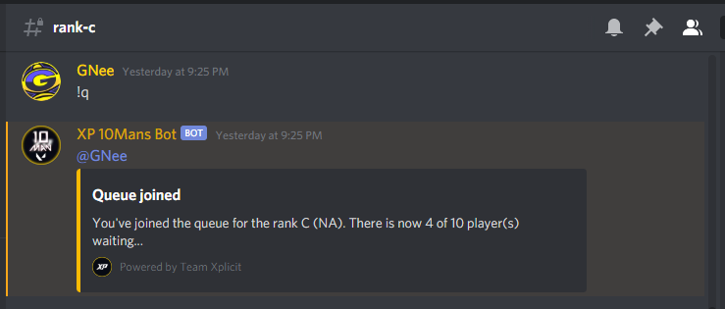

Once a queue reaches 10 members, it will begin the match process.

- You will first be asked to join the Voice channel that correlates to your match number. Once everyone has joined, You will be asked to vote for captains or pick one randomly.

- Once the captains have been picked, teams will automatically be generated, and everyone split into two different voice channels

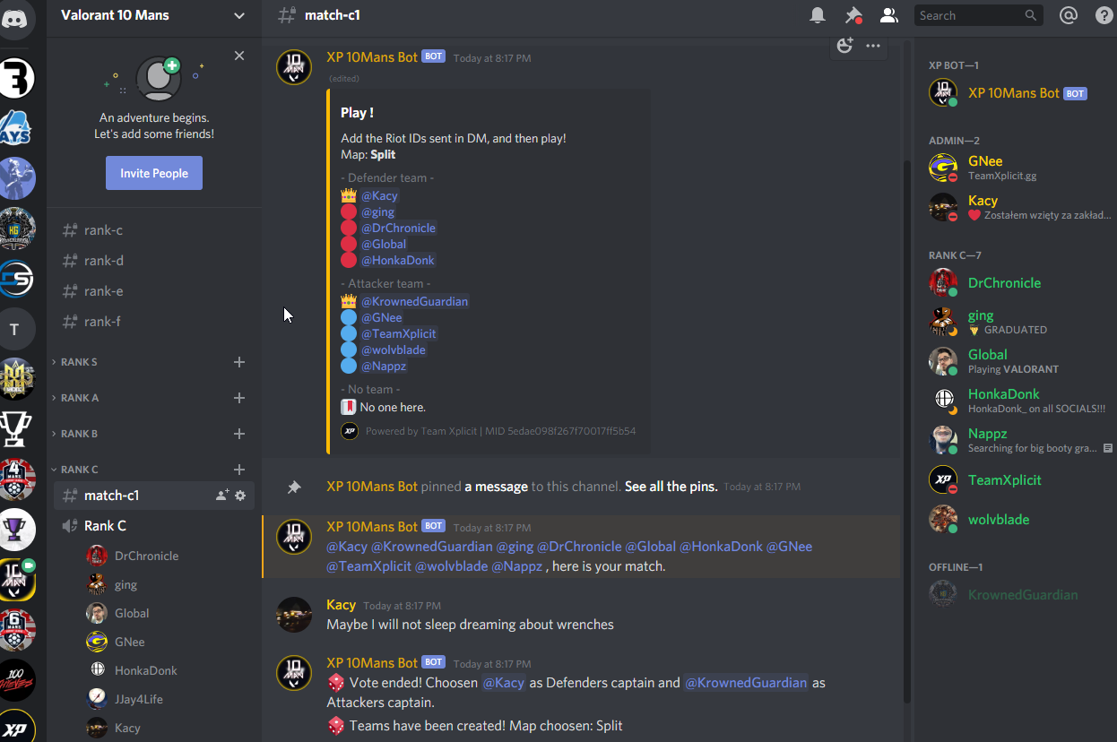

After teams have been picked, Players on each team will be sent the captains Riot ID for them to add on riot. (Captains are expected to add one another and then add their teammates to the party that has been created. This should make the process smooth.

The Attacker captain will always be host unless it has been discussed that another player can host. The map to be played on should be displayed in the your match-chat

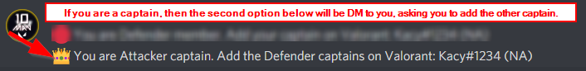

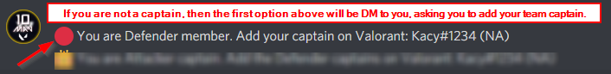

After the game as concluded, the captain of the winning team will log the game win in the #match-result channel. Put **!w** in **#match-result channel** and you will be sent a dm to log in the score.

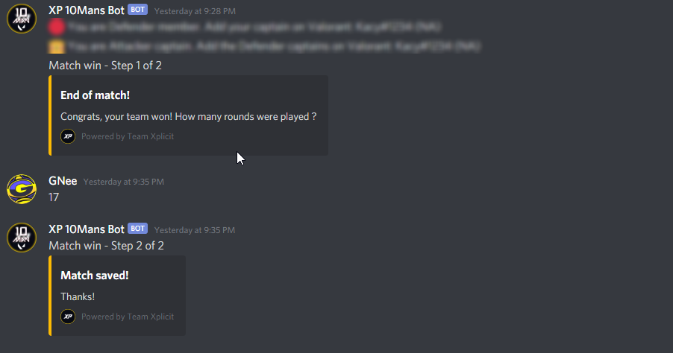

Final results of the match will be posted for everyone to see in the **#match-result channel**

